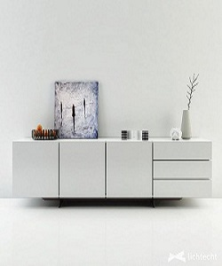

Modern and stylish Poliform storage Cabinet

$124.18

Availability: In stock

### Description

Poliform Storage Cabinet with special light white sheet that enhance the exclusive quality of the wood. It is easy to open and close. The finish and contemporary design are adaptable for any decor style. There is many space you can store many things safely. Available in different size and colors in affordable prizes.